Published: THE SINGLETON ARGUS: http://www.singletonargus.com.au/story/1708072/veterans-come-together/?cs=1282

VIETNAM VETERANS’ TOGETHER

By Di Sneddon
Aug. 16, 2013, 5:30 a.m. 20130816F; tfd1-3; 0730h

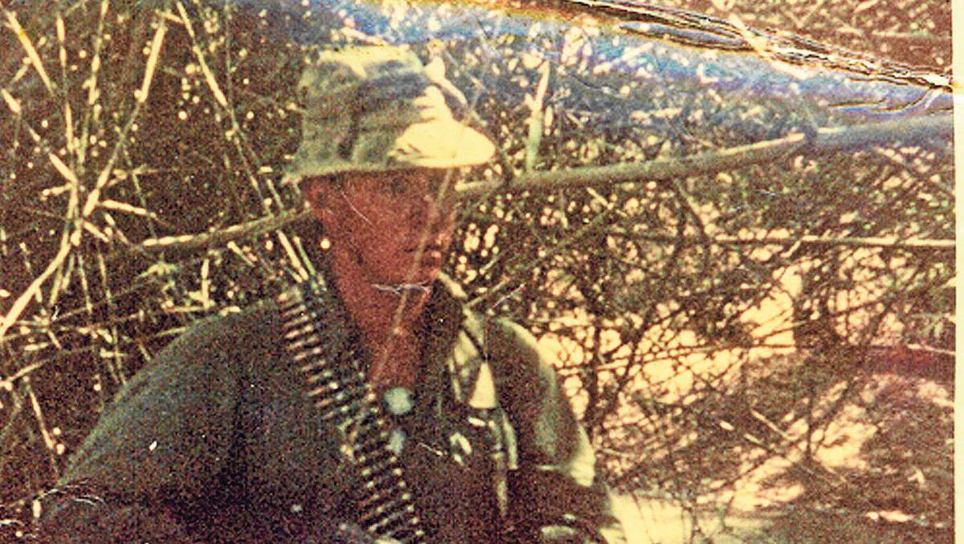
Paul at the Warburton Mountains.

PAUL Carpenter turned 21 years of age while training at Canungra for the Vietnam War.
He, like many around him, had been conscripted.
When his name came out in the draw, he was in shock. He didn’t want to go anywhere and was apprehensive.
“I didn’t like being told what to do,” he said reflecting on a period in his life that would have long lasting impacts.
It was back in 1968 and although that was 45 years ago, those memories come flooding back to Paul as if it was yesterday.
When he arrived at Saigon airport his life underwent a drastic change.
“It was crazy, all we could see was army personnel, fighter jets, holes in the tarmac and people with guns.”
He was an army engineer and he won’t admit it but probably had one of the most vulnerable roles in Vietnam at the time.
He says there was no-where in Vietnam that was completely safe but as a member of the land clearing team he spent most of his time ‘out bush’.
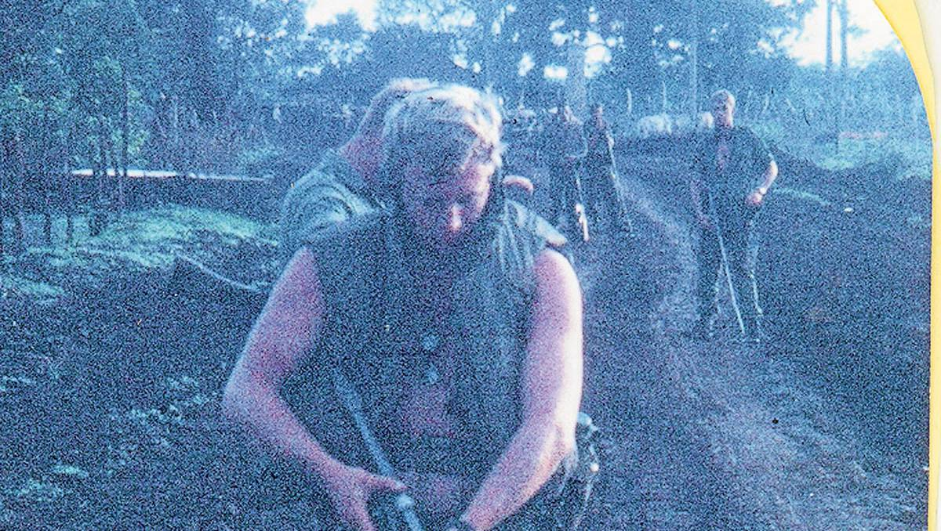
Paul at Dat Do district.

The land clearing team’s responsibility was to clear land around villages to make it more difficult for the Viet Kong to raid for supplies.
He and good mate Lyle Gates from Melbourne were a mini-team.
The pair had the job of ensuring the land to be cleared was free of enemy, land mines and booby traps prior to the dozer team coming in.
Armed with nothing but mine detectors and a rifle, the pair would set out on foot to render the area safe.
It was rough terrain, full of timber and debri and those booby traps came in all shapes and weren’t always found.
One of those traps consisted of ceramic jars filled with wasps.
Paul remembers seeing the dozer drivers running for their lives after hitting one of the jars.
“As you can imagine the wasps weren’t happy and those blokes came back with hundreds of stings, some of them never returned to the job they were stung that badly,” Paul said.
It was a job he did for 12 months and all he wanted to do was go home.
The only thing that kept him going was the blokes he stood beside, among them his Melbourne mate Lyle Gates.
On Vietnam Veterans day he will catch up with Lyle and a few others he served with.

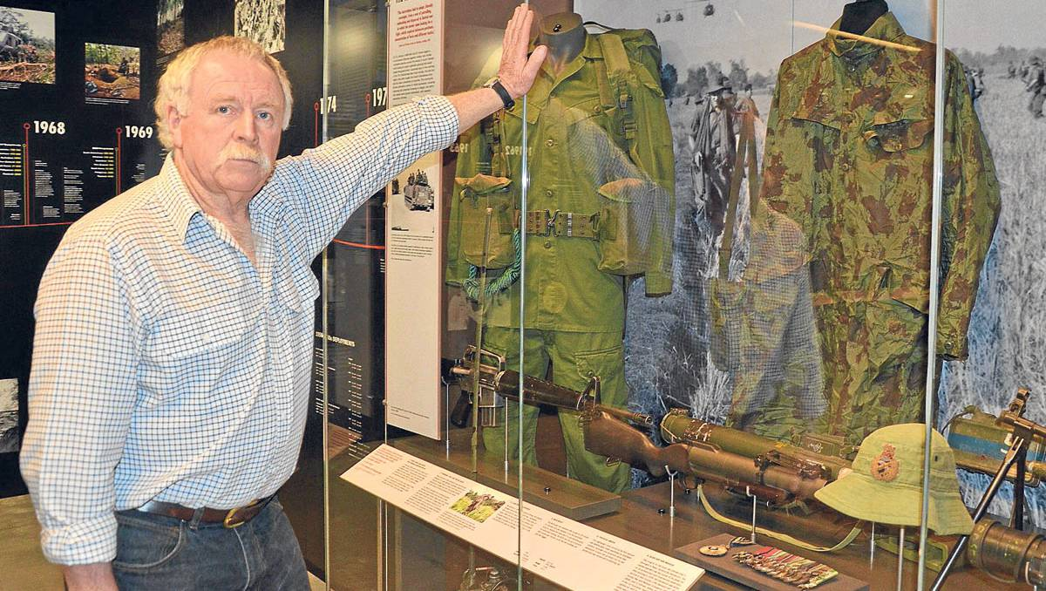
LOOKING BACK: Paul Carpenter at the Australian Infantry Museum’s dedicated display on the Vietnam War. The museum is open on Vietnam Veterans Day from 9am to 4pm and a service will be held in Singleton on Sunday on the village green in front of the Civic Centre at 10:30am.

It is a day to relax and say things that no-one else would understand.
Working side-by-side with Lyle in such dangerous conditions brought a bond between the two that only those who have experienced such a friendship would understand.
“If I was looking for a mine Lyle would hold my rifle and I’d do the same for him, we trusted each other with our lives, we had to,” Paul said.
It was hard coming back home.
There was no support and the vets were simply told to get on with it and go find a job.
Paul got a job in the mining industry but those memories of what he went through caught up with him about ten years ago.
He spent eight weeks in a psychiatric ward to learn to cope with his demons and says he wished he did it years before.
“I never talk about Vietnam to anyone who didn’t go, it is just too foreign and that’s why Vietnam Veterans day is so important to the vets,” Paul said.

20130816F; tfd1-3; 0730h

